6Les10-create manage tables

Chapter 10

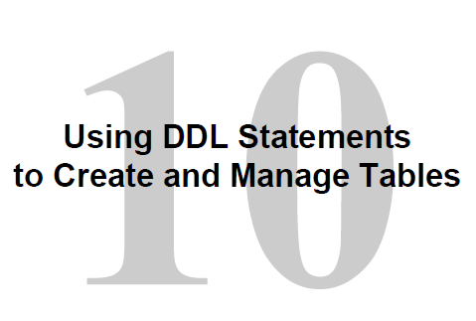

Objectives

# After completing this lesson, you should be able to do the following:

# • Categorize the main database objects

# • Review the table structure

# • List the data types that are available for columns

# • Create a simple table

Alter the table

Delete the table

# • Explain how constraints are created at the time of table creation

Inline constraints

Out of line constraints

Exception complaints

# • Describe how schema objects work

**Lesson Agenda**

• Database objects

– Naming rules

• CREATE TABLE statement:

– Access another user’s tables

– DEFAULT option

• Data types

• Overview of constraints: NOT NULL, UNIQUE, PRIMARY

KEY, FOREIGN KEY, CHECK constraints

• Creating a table using a subquery

• ALTER TABLE

– Read-only tables

## • DROP TABLE statement

Database Objects



Types of OBJECTS – the term object will appear on the exam

|  |  |
| --- | --- |
| OBJECT | DESCRIPTION |
| Table | Basic storage unit composed of rows of data divided into columns of fields |
| View | Logical representation of data from 1 or more tables. Not physical |
| Sequence | Generate numeric values. Example invoice numbers, employee id etc. |
| Index | Improves performance for some queries. Done later |
| Synonym | Gives an alternate name to an object. |



****************** THERE ARE OTHER OBJECTS ************

A **sequence** is an object in **Oracle** that is used to generate a number **sequence**. This can be useful when you need to create a unique number to act as a primary key. 🡺 auto number

An **index** helps just like an index in a book or manual that speeds up the search through the manual. It will make queries faster. Not all tables require an index

A **synonym** is an alternative name for objects such as tables, views, sequences, stored procedures, and other database objects. You generally use **synonyms** when you are granting access to an object from another schema and you don't want the users to have to worry about knowing which schema owns the object.

**Oracle Table Structures**

• Tables can be created at any time, even when users are using the database.

• You do not need to specify the size of a table.

The size is ultimately defined by the amount of space allocated to the database as a whole.

It is important, however, to estimate how much space a table will use over time.

• Table structure can be modified online.

.

Naming Rules

**Table names and column names must**:

• Begin with a letter

• Be 1–30 characters long

• Contain only A–Z, a–z, 0–9, _, $, and #

• Cannot duplicate the name of another object owned by the same user

• Cannot be an Oracle server–reserved word

🡺 🡺 Names are NOT case sensitive



**Lesson Agenda**

• Database objects

– Naming rules

• CREATE TABLE statement:

– Access another user’s tables

– DEFAULT option

• Data types

• Overview of constraints: NOT NULL, UNIQUE, PRIMARY

KEY, FOREIGN KEY, CHECK constraints

• Creating a table using a subquery

• ALTER TABLE

– Read-only tables

• DROP TABLE statement

Create table

(much of this is similar to DBS201)

You must have (a) privilege

(b) must be storage area available

General Syntax

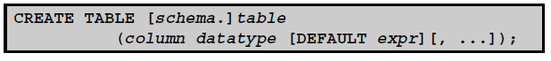

Basically, you provide

- Table name

- Column name

- Data type

- Size

NOTE: because as students we are working in one schema, the schema name can be left off

Referencing table of other users

Schema is a collection of logical structures of data known as a schema object

Schemas are owned by a user and has the same name as that user.

Each owner has a single schema.

To access a table in another schema you need to qualify the name. Like iSeries in DBS201

SELECT *

FROM PREMIER.employees;

Create table

You should at least type or cut and paste these statements in so you can try them. Good practice to help you remember.

# **Create a table with 4 columns**.

Specified:

1 Table name 🡺 dept

2 Column Names

3 Data type of each column

4 Size (date has a specific size built in)

**CREATE TABLE dept**

**( deptno NUMBER(2),**

**dname VARCHAR2(14),**

**loc VARCHAR2(13),**

**create_date DATE**

**);**

# **Confirm creation**

**DESCRIBE dept**

# Do a rollback to see what happens

**rollback**

# **How to query what tables you own**

**SELECT TABLE_NAME**

**FROM USER_TABLES;**



Default Option

- You can specify a default option that effects data being inserted

- the default data type must match the column data type

EXAMPLE:

**CREATE TABLE HIRE_DATES**

**( ID NUMBER(8),**

**HIRE_DATE DATE DEFAULT SYSDATE);**

On the insert, if no value specified the system date will be inserted along with the ID

- You can specify NULL if you don't want any data

# Example of a good use of default:

In the assignment example a default city might be Hamilton, since the Real Estate company mainly sold properties in Hamilton.

**Lesson Agenda**

• Database objects

– Naming rules

• CREATE TABLE statement:

– Access another user’s tables

– DEFAULT option

• Data types

• Overview of constraints: NOT NULL, UNIQUE, PRIMARY

KEY, FOREIGN KEY, CHECK constraints

• Creating a table using a subquery

• ALTER TABLE

– Read-only tables

• DROP TABLE statement

Data types available

(Not all will be covered on this course)

The first 4 will be the most common

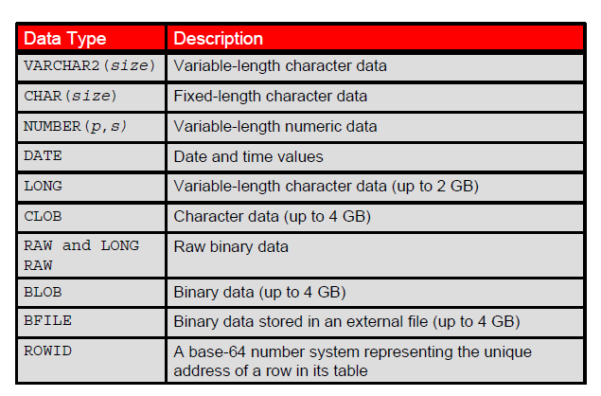



VARCHAR2 (size) Maximum size needs to be specified (up to 4000)

CHAR Fixed Length size to maximum 2000

NUMBER (p, s) P is precision or total number of decimal digit and

S is scale or number of digits to the right of the decimal point

EX: NUMBER (5, 2) means 5 all together and 2 decimal places

The value 1000 will be rejected by the server as that is 6 wide

DATE Date and Time value to the nearest second

Range: Jan 1, 4712 BC and Dec 31, 9999

==========================================================================

LONG data type is variable length up to 2GB

CLOB character data up to 4GB

Others you will encounter in later courses

**Data Type Description**

RAW(*size*) Raw binary data of length *size* (A maximum *size* must be specified: maximum *size* is 2,000.)

LONG RAW Raw binary data of variable length (up to 2 GB)

BLOB Binary data (up to 4 GB)

BFILE Binary data stored in an external file (up to 4 GB)

ROWID A base-64 number system representing the unique address of a row in its table

DATETIME data types

TIMESTAMP - By default this is in microsecond

- EX: 12-MAR-17 08:45.23.123456 🡸 6 decimals for microseconds

TIMESTAMP (0) - removes part seconds

TIMESTAMP (9) - can go to nanoseconds

On more advanced courses

INTERVAL to MONTH 15-4 is how it is store 15 years 4 months

- Instead of 5773 days

INTERVAL TO SECOND 3 12:42:21 3 days 12 hours etc…

- Use in biochemistry and other fields to mark time passed

Lesson Agenda

• Database objects

– Naming rules

• CREATE TABLE statement:

– Access another user’s tables

– DEFAULT option

• Data types

• Overview of constraints: NOT NULL, UNIQUE, PRIMARY KEY, FOREIGN KEY, CHECK constraints

• Creating a table using a subquery

• ALTER TABLE

– Read-only tables

• DROP TABLE

Constraints

Constraints enforce rules at the table level

- prevent adding data to a child table without the parent table data

- prevents deleting parent table or row when child data exists

- ensures correctness of data entered

- reduces programming, since database looks after validation of data entered rather than each program

# **Types of Constraints**

|  |  |
| --- | --- |
| NOT NULL | - SPECIFY DATA CANNOT BE null |
| UNIQUE | - PREVENTS DUPLICATION OF DATA IN THE OTHER ROWS (OHIP) |
| PRIMARY KEY | Unique identifier for each row in a table  Aside: It is both NOT NULL and UNIQUE |
| FOREIGN KEY | Establishes and enforces a referential integrity between the column and a column of the referenced table such that values in one table match values in another table |
| CHECK | Specifies a TRUE condition |

Constraint Guidelines

# • You can name a constraint (good idea),

# OR

# The Oracle server generates a name by using the SYS_C*n* format.

# 🡺 best to name the constraint

# • Create a constraint at either of the following times:

# – At the same time as the creation of the table

# – After the creation of the table 🡨 via the ALTER statement

# • Define a constraint at the column or table level.

-- INLINE – done as the column is defined

-- OUTLINE – done at end of column definitions but still in the create table statement

# • View a constraint in the data dictionary.

# NOTE:

One constraint can only be done at the table level

When more than 1 key is needed for the Primary Key

Composite key

Concatenated key

Constraints – defined

Generic syntax:

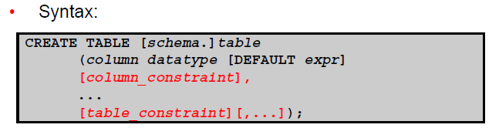

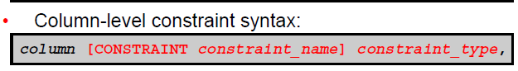

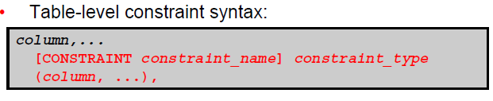

CONSTRAINT – Examples



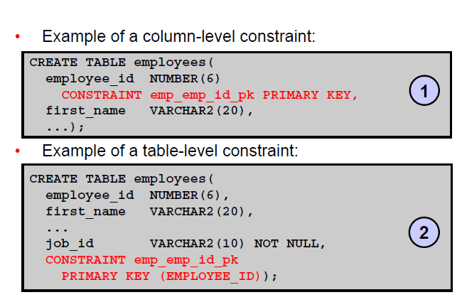



NOTE:

**COLUMN LEVEL**

The comma goes AFTER the constraint on the column level

The column name is NOT specified because it is on the column definition

Naming convention – TABLE_COLUMN_TYPE -- example: department_dept_id_pk

**TABLE LEVEL**

After the last comma

Column needs to be specified

NOTE: Can only apply one PK constraint at the column level. For concatenated keys, done at table level.

CREATE TABLE STUDENT-COURSE (

STUDENT_ID NUMBER (9),



IMPORTANT

COURSE_ID CHAR(6),



GRADE CHAR(1),



**CONSTRAINT STUD_CRSE_STUD_ID_CRSE_ID_pk**

**PRIMARY KEY (STUDENT_ID, COURSE_ID)**

);

NOT NULL -- What does it do?

Sample data in a table

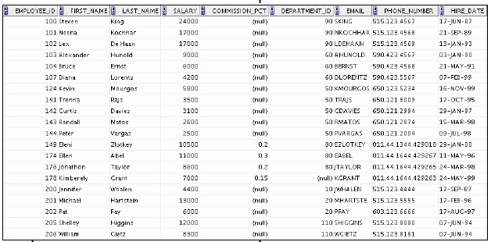

PK -- enforces a NOT NULL and UNQUE

This column has no constraint so can be NULL

The remainder have NOT NULL constraints

UNIQUE

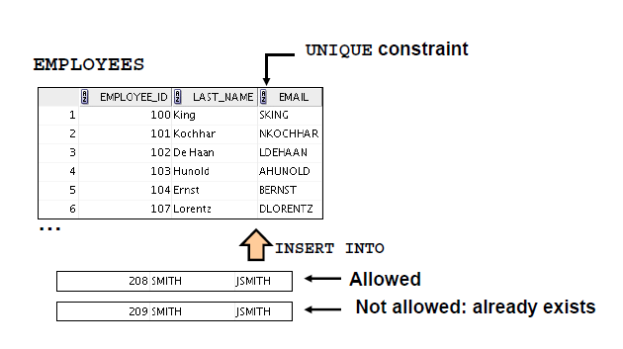

NOTE:

1 Can describe a COMPOSITE UNIQUE KEY made of more than one column

2 Can contain NULL – Null satisfies the UNIQUE because null is not equal to anything

3 On a composite Unique you cannot have duplicates in the non-null part

UNIQUE CONSTRAINT

# Example: At the TABLE LEVEL

**CREATE TABLE employees(**

**employee_id NUMBER(6),**

**last_name VARCHAR2(25) NOT NULL,**

**email VARCHAR2(25),**

**salary NUMBER(8,2),**

**commission_pct NUMBER(2,2),**

**hire_date DATE NOT NULL,**

**...**

**CONSTRAINT emp_email_uk UNIQUE(email));**

PRIMARY KEY

**EXISTING TABLE:**

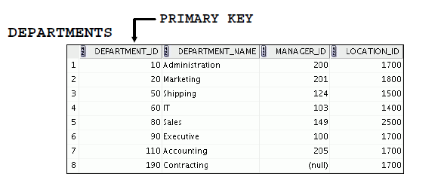

**Example of Insert data**

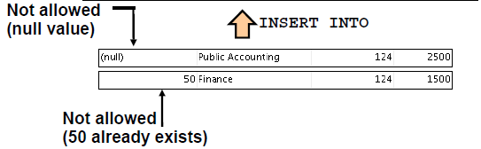

FOREIGN KEY

Established referential integrity.

Designate a column or group of columns as a foreign key.

Establishes a relationship with a primary key or a unique key in the same table or a different table.

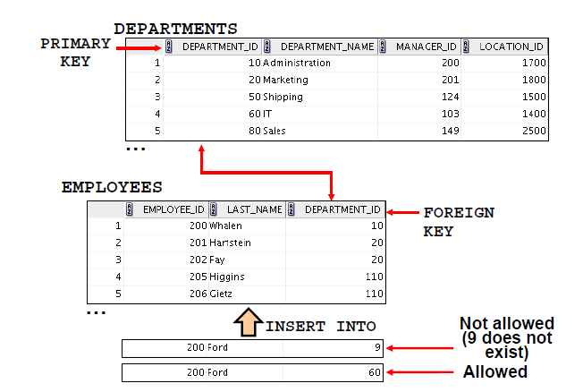



**NOTE: Foreign key MUST match an existing value in the parent table**

**OR … it must be NULL**

**Example of NULL usage. Add an employee but they have not yet been assigned a department to work for.**

Foreign Key – table level

**CREATE TABLE employees(**

**employee_id NUMBER(6),**

**last_name VARCHAR2(25) NOT NULL,**

**email VARCHAR2(25),**

**salary NUMBER(8,2),**

**commission_pct NUMBER(2,2),**

**hire_date DATE NOT NULL,**

**...**

**department_id NUMBER(4),**

**CONSTRAINT emp_dept_fk FOREIGN KEY (department_id)**

**REFERENCES departments(department_id),**

**CONSTRAINT emp_email_uk UNIQUE(email));**

Foreign Key – column level

**CREATE TABLE employees**

**(...**

**department_id NUMBER(4) CONSTRAINT emp_deptid_fk**

**REFERENCES departments(department_id),**

**...**

**)**



**NOTE:**

**Foreign Key not stated in above example. The use of the word reference handles that concept that this is a foreign key constraint**

**Still need to name it and specify what it references**

**At table level need to say FOREIGN KEY**

FOREIGN KEY

Constraint: Keywords

• FOREIGN KEY: Defines the column in the child table at the table-constraint level

• REFERENCES: Identifies the table and column in the parent table

2 more options- later in course

The parent record cannot be changed or deleted if there exists an FK in the child table that references it. This is done to maintain the integrity of the data

• ON DELETE CASCADE: Deletes the dependent rows in the child table when a row in the parent table is deleted

• ON DELETE SET NULL: Converts dependent foreign key values to null

CHECK CONSTRAINT

# **Defines a condition that each row must satisfy before the insert can be added to the table**

**EXAMPLE:**

**CREATE TABLE EMPLOEES**

**( …. other columns**

**salary NUMBER(2)**

**CONSTRAINT employees_salary_min CHECK (salary > 0),**

**...**

**)**

FULL EXAMPLE

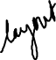

CREATE TABLE employees



( employee_id NUMBER(6)

CONSTRAINT emp_employee_id PRIMARY KEY

, first_name VARCHAR2(20)



, last_name VARCHAR2(25)

CONSTRAINT emp_last_name_nn NOT NULL

, email VARCHAR2(25)

Can have 2 constraints

CONSTRAINT emp_email_nn NOT NULL

CONSTRAINT emp_email_uk UNIQUE

, phone_number VARCHAR2(20)

, hire_date DATE

CONSTRAINT emp_hire_date_nn NOT NULL

, job_id VARCHAR2(10)

CONSTRAINT emp_job_nn NOT NULL

, salary NUMBER(8,2)

CONSTRAINT emp_salary_ck CHECK (salary>0)

, commission_pct NUMBER(2,2)

, manager_id NUMBER(6)

CONSTRAINT emp_manager_fk REFERENCES employees (employee_id)

Self referencing

, department_id NUMBER(4)

CONSTRAINT emp_dept_fk REFERENCES departments (department_id)

);

Violating Constraints

# **Changing department ID from 110 to 55**

**UPDATE employees**

**SET department_id = 55**

**WHERE department_id = 110;**

# **Here is the error**

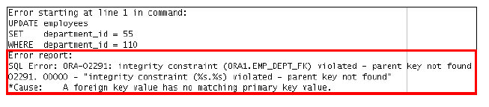



NOTE: The name of constraint is stated in the error message. From that message, we know

Table: EMP or EMPLOYEES

Column: Department_id

Cause: A foreign key value has no matching PK value



Violating Constraints – on a delete

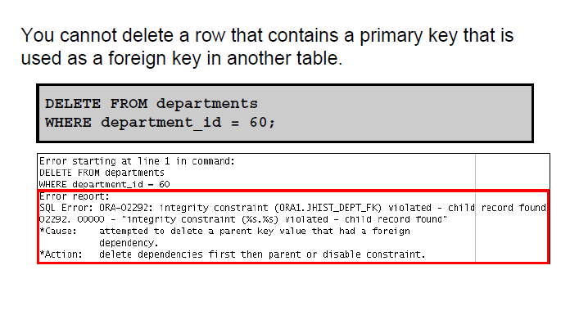



# **EXAMPLE of a delete that works**

DELETE FROM departments

WHERE department_id = 70; 🡸 because there are no employees in department 70

Lesson Agenda

• Database objects

– Naming rules

• CREATE TABLE statement:

– Access another user’s tables

– DEFAULT option

• Data types

• Overview of constraints: NOT NULL, UNIQUE, PRIMARY KEY, FOREIGN KEY, CHECK constraints

• Creating a table using a subquery

• ALTER TABLE

– Read-only tables

• DROP TABLE statement

Creating a table – via a subquery

• Create a table and insert rows by combining the

CREATE TABLE statement and the

AS *subquery* option.

Generic Syntax:

**CREATE TABLE *table***

**[(*column*, *column*...)]**

**AS *subquery;***

Match the number of specified columns to the number of subquery columns.

Define columns with column names and default values

-- see examples

CREATE TABLE using subquery

**CREATE TABLE dept80**

**AS**

**SELECT employee_id, last_name, salary*12 ANNSAL, hire_date**

**FROM employees**

**WHERE department_id = 80;**

DESCRIBE dept80

Notice an alias for a non-existing column

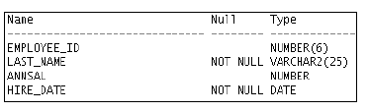

# **Alias not used 🡺 generates an error**

Salary*12 does not exist as a column

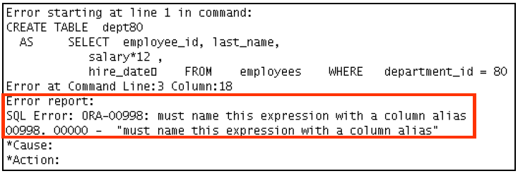



Lesson Agenda

• Database objects

– Naming rules

• CREATE TABLE statement:

– Access another user’s tables

– DEFAULT option

• Data types

• Overview of constraints: NOT NULL, UNIQUE, PRIMARY KEY, FOREIGN KEY, CHECK constraints

• Creating a table using a subquery

• ALTER TABLE

– Read-only tables

• DROP TABLE statement

ALTER TABLE Statement

Use the ALTER TABLE statement to:

• Add a new column

• Modify an existing column definition

• Define a default value for the new column

• Drop a column

• Rename a column

• Change table to read-only status

Read-Only Tables

# **When changes are being made to the table it is a good idea to put the table into read-only mode**

ALTER TABLE employees READ ONLY;

---- make the changes

ALTER TABLE employees READ WRITE;

In the environment of a student that wouldn't be done as you are not updating data in a table at the same time as maintenance to the table is being done --- you are the only user.

ASIDE:

You can drop a table that is in the READ ONLY mode. The DROP command is executed only in the data dictionary, so access to the table contents is not required. The space used by the table will not be reclaimed until the tablespace is made read/write again, and then the required changes can be made to the block segment headers, and so on.

Lesson Agenda

• Database objects

– Naming rules

• CREATE TABLE statement:

– Access another user’s tables

– DEFAULT option

• Data types

• Overview of constraints: NOT NULL, UNIQUE, PRIMARY KEY, FOREIGN KEY, CHECK constraints

• Creating a table using a subquery

• ALTER TABLE

– Read-only tables

• DROP TABLE statement

Finally at the end topic

Dropping a Table

DROP TABLE employees -- (don't test this)

Moves a table to the recycle bin

Removes the table and all its data entirely

- If PURGE specified it releases space for other objects to use

Invalidates dependent objects and removes object privileges on the table

- Views using the table remain, but are invalid

NOTE: There is a way of getting a table back from the recycle bin … see FLASHBACK in a later course

SO FAR: 🡺

Added a table to the database 🡺 CREATE

Removed a table from the database 🡺 DROP

**Quiz**

You can use constraints to do the following T or F:

1. Enforce rules on the data in a table whenever a row is inserted, updated, or deleted.

2. Prevent the deletion of a table.

3. Prevent the creation of a table.

4. Prevent the creation of data in a table.

124